**Assignment -4**

|  |  |
| --- | --- |
| **Assignment Date** | 05-11-22 |
| **Student Name** | M.SUBASH |
| **Student Roll Number** | 814619104019 |
| **Maximum Marks** | 2 marks |

***SMS SPAM Classification***

**Importing of Libraries**

import numpy as np  
import pandas as pd  
import matplotlib.pyplot as plt  
import seaborn as sns  
import scipy as sp  
from google.colab import drive  
from sklearn import feature_extraction, model_selection, naive_bayes, metrics, svm  
from sklearn.ensemble import RandomForestClassifier  
from sklearn.model_selection import train_test_split  
from sklearn.metrics import precision_recall_fscore_support as score  
%matplotlib inline  
drive.mount('/content/drive')

**ADD LAYERS**

# Create a dataframe  
metrics = pd.DataFrame(history.history)# Rename column  
metrics.rename(columns = {'loss': 'Training_Loss', 'accuracy': 'Training_Accuracy',  
 'val_loss': 'Validation_Loss', 'val_accuracy': 'Validation_Accuracy'}, inplace = True)  
def plot_graphs1(var1, var2, string):  
 metrics[[var1, var2]].plot()  
 plt.title('LSTM Model: Training and Validation ' + string)  
 plt.xlabel ('Number of epochs')  
 plt.ylabel(string)  
 plt.legend([var1, var2])plot_graphs1('Training_Loss', 'Validation_Loss', 'loss')  
plot_graphs1('Training_Accuracy', 'Validation_Accuracy', 'accuracy')

**COMPILATION MODEL**

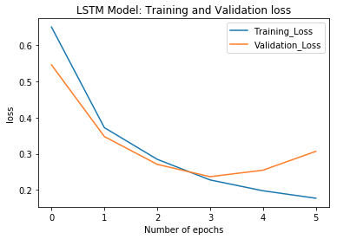

**Tested Model**

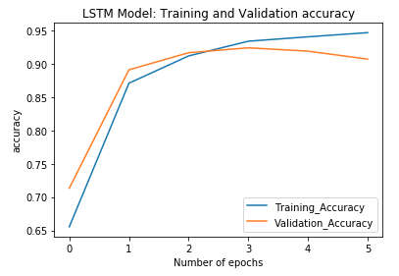

Keeping track of accuracy over epochs: LSTM